REPORT FOR MY PROJECT ON HTML, CSS, JAVA SCRIPT

HIGHER INSTITUTE OF MANAGEMENT SCIENCE

This webpage is easy to know about how, webpages interact with each device. We will be talking about .
- HTML.
- CSS.
- JAVA SCRIPT.
It should be noted that all this are web development languages. And we will be explaining each of them and how they interact and their uses on web pages.

HTML
This is a full meaning of HYPER TEXT MARKUP LANGUAGE . And it is used to design the main scope of the web page. This is without beauty of the web page. This is where CSS now comes in.

CSS
The full meaning of CSS stands for CASCADING STYLE SHEET. The use is to make our website to look pretty and good to navigate through. It helps us add different colors and position our tools or contents of our web site where we want them to be.

JAVA SCRIPT 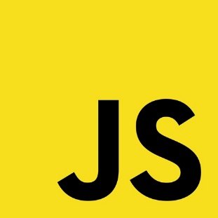

Java script now comes in with its own syntags to add live to the webpage. It helps the webpage to be interactive and also user friendly. It helps the user to be able to use the site on any device easily.
So as on this I learnt a lot about how each and every webpage works, and how to make them intereactive.

